**SUCCESS STORY of Mrs. Kimneithem**

**Lengchonghoih SHG, K. Lhangnom Village.**

Hailing from the interior region of Churachandpur District, Mrs Kimneithem is a resident of K. Lhangnom village which is situated at approximately 18kms from the heart of Lamka Town, the District's Headquarter. The village is a predominantly Thadou/Kuki speaking community with a total household of 41. It is situated near Tuining village with the Tuining stream separating the two villages and falls under Sangaikoi TD Block. Travelling from Lamka town towards this village is usually via a semi-pucca road up till Tuining village, and from which onwards it is a stretch of kutcha road usually non-motorable during rainy season.

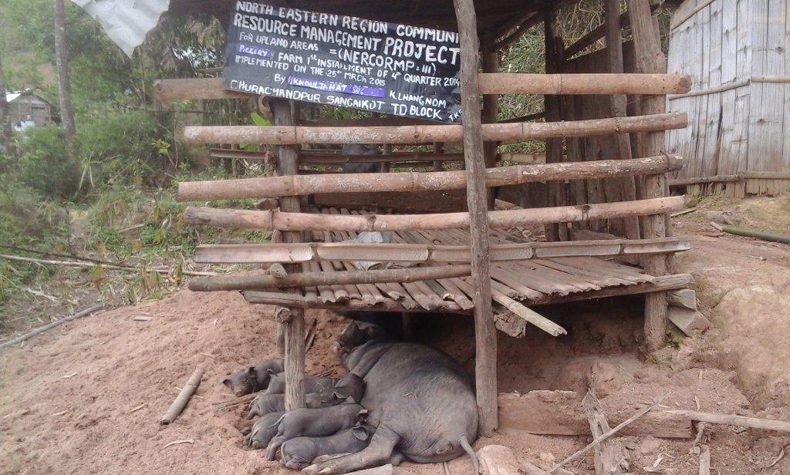

Ever since the introduction of NERCORMP Project in the village during the year 2014 and the formation of K Lhangnom NaRM-G and 4 SHG's - namely Lengchonghoi SHG, Kholzahat SHG, Zozam SHG and Kinepna SHG.

Mrs.Kimneithem, aged 36yrs, is a mother of 3 and lives in a mud-walled house with her extended family of in-laws and other relatives. Currently she is serving as the Secretary for Lengchonghoi SHG and has been a dedicated member ever since the formation of the group. Coming from an economically backward class and residing in the interior part of the District, although it may seem appealing to a wayward tourist or a jaywalker, the determined mother states that life has been really trying most of the time with having to depend on menial, gruesome jobs that takes a toll on one's health - with burning charcoal, collecting firewood, and working in the field being one of the easier jobs that one needed to do so as to earn a day's living. Besides the unavailability of activities to generate a steady source of income, no household land nor the amount needed to buy or rear animals which may serve as liquefiable assets in case of an emergency, and having to deal with the needs of 3 children who are yet unable to fend for themselves, Mrs.Kimneithem bears a heavy burden on her shoulders which at times seems to have taken a toll on her.

In her own words, Mrs.Kimneithem talks about the earlier days of suffering and hardships that she as well as the community faced before NERCORMP was introduced, and the present state in which it now has played a major role in their everyday life, stating that "..the burden of the past days of suffering and economic hardships has been greatly removed and has brought to us a much needed relief.." With the introduction of NERCORMP and the formation of Self Help Groups within the village and the funds received through NERCORMP, Mrs.Kimneithem was now in a much better condition than before.

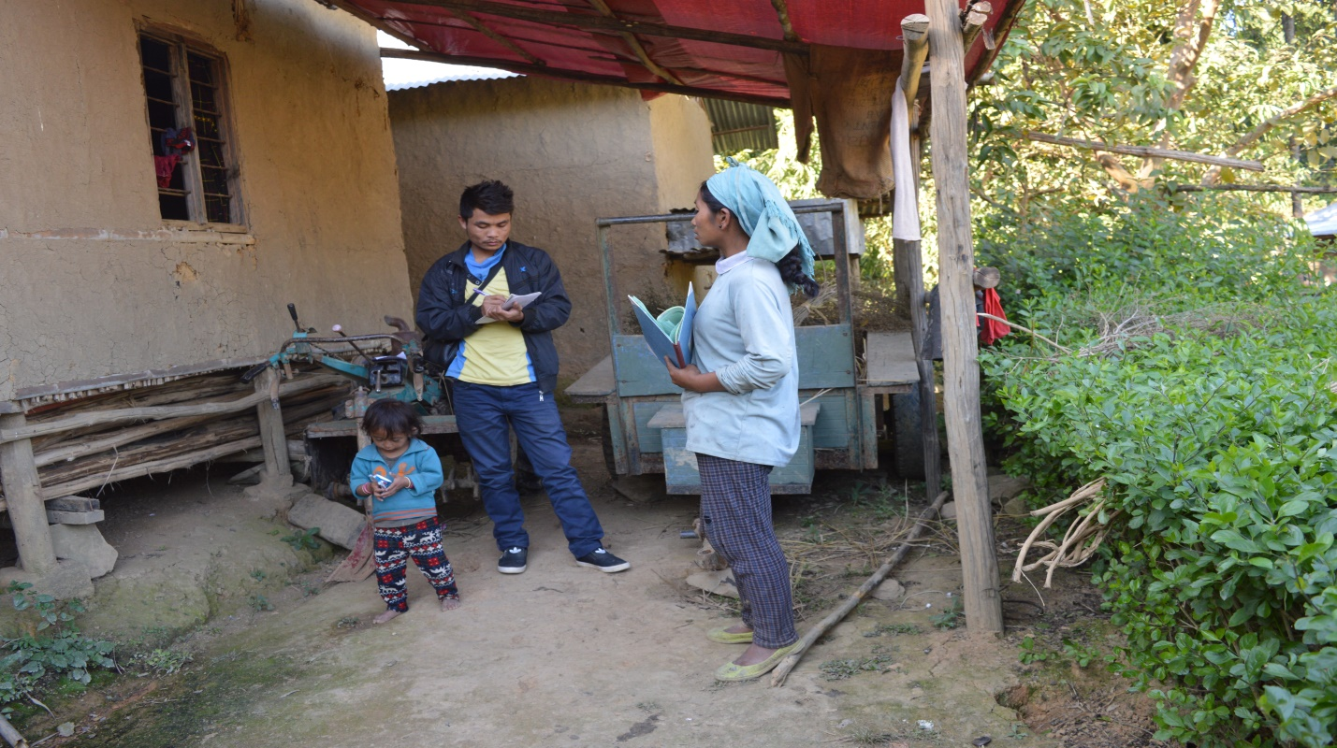

Being one of the first recipient of the Funds that were disbursed through Lengchonghoi SHG, wherein she received a sum of Rs 6600,Mrs.kimneithem initially purchased a certain number of piglets which she reared until she was able to repay back the said amount of loan that was given to her while in the meantime continuing to rear the remaining pigs from which she further received offsprings so as to raise enough amount for the purchase of a 'Kabuta' which she has always wanted to own as she believed that it could aid her in ploughing the fields as well as to be rented thus serving as a steady source of income and a promise of a better living standard. Thus with the money she obtained from the sale of the pigs that she reared and adding a little more to it from her savings, she was able to purchase a second-hand 'Kabuta' which she proudly displays to us as she beams with delight at finally having achieved what she had always wanted for a long time.

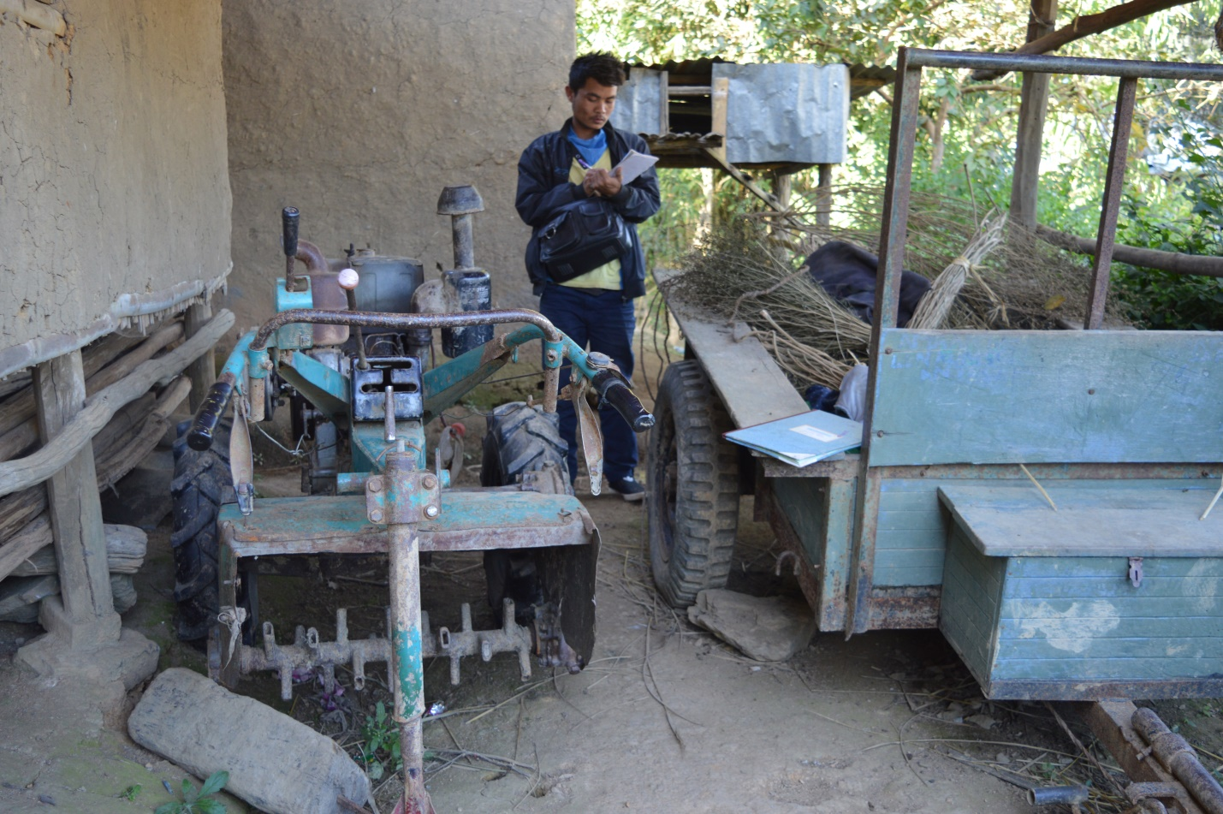

Now with the acquisition of the 'Kabuta' and a future that promises to be better than her past, Mrs.Kimneithem is a fervent believer that better days are yet to come as her hopes have been rejuvenated and the future looks to be settled. Finally, she waves us off by stating that with the help and support from NERCORMP, better days are yet to come not only for her but for the community and the village as a whole.

(Story capture and compiled by Mr. M. Kapsutlian, Supervising Officer , Action for Women and Child Advancedment (AWCA), during a field visit to K. Lhangnom village which is one of the many villages cover by NERCORMP –III project under Sangaikot TD block, Churachandpur, Manipur.)